

ASSIGNMENT ON STRING FUNCTION

PROGRAMMING IN C



SUBMITTED BY: MELBIN JOJO SUBMITTED TO:LINU MISS

DEPARTMENT : (BCA 1ST YEAR)

ROLL NO:27

***STRING HANDLING FUNCTIONS***

**C language supports a large number of string handling functions that can be used to carry out many of the string manipulations.**

**These functions are packaged in string.h library. Hence we must include string.h header file in our program to use these functions.**

Some of the most commonly used string handling functions are:

1. strcat():

It is used to combine two strings.

Eg: program to combine two strings.

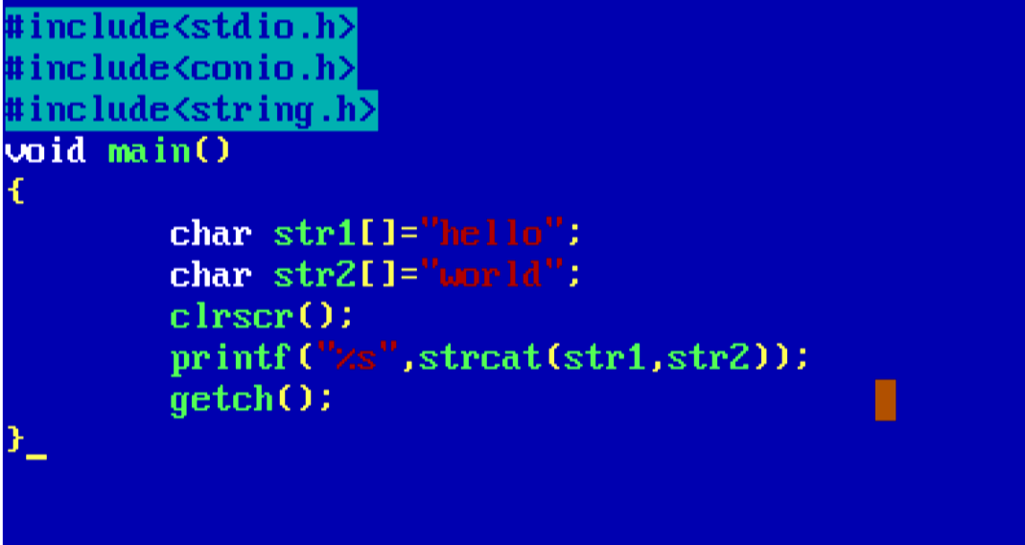

**Output:**

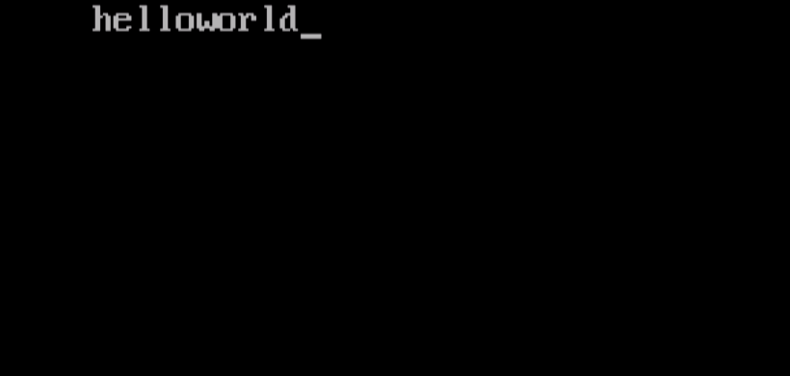

1. strlen():

Used to find the length of the string.

Eg:program to find the length of string.

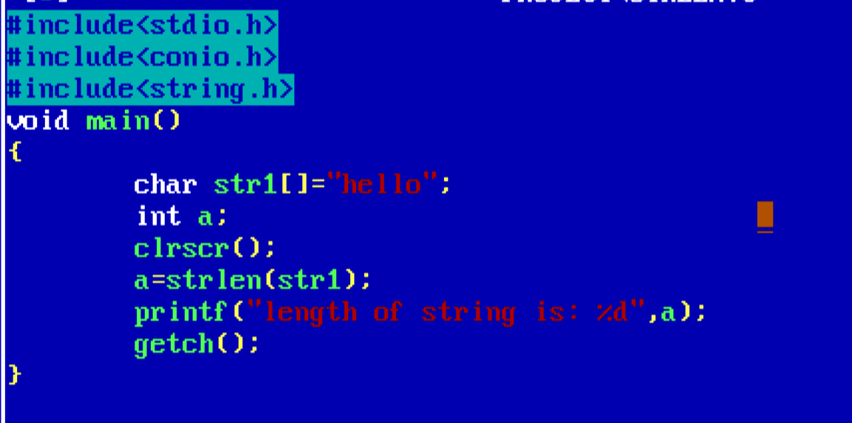

**Output:**

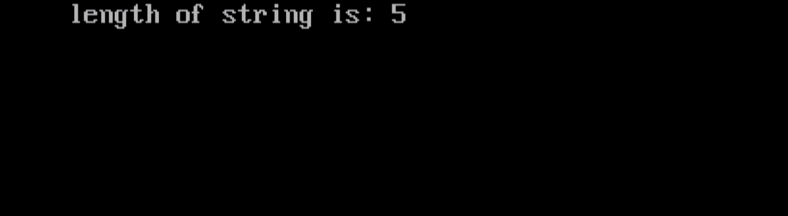

**3**.strrev():

Used to reverse the order of string.

Eg : program to print a string in reverse order.

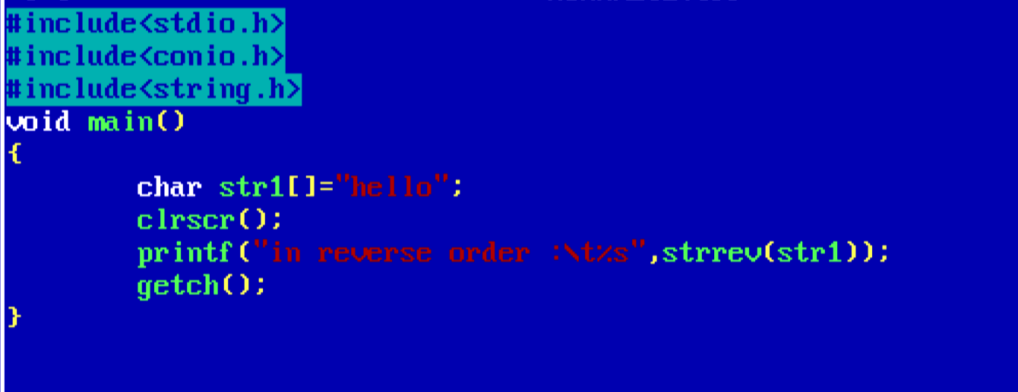

**Output:**

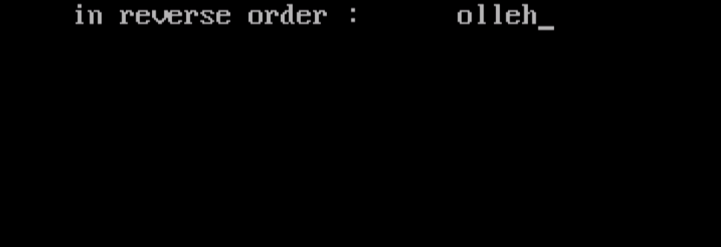

4.strcpy():

Used to copy one string to another.

Eg : program to copy one string to another and print it.

***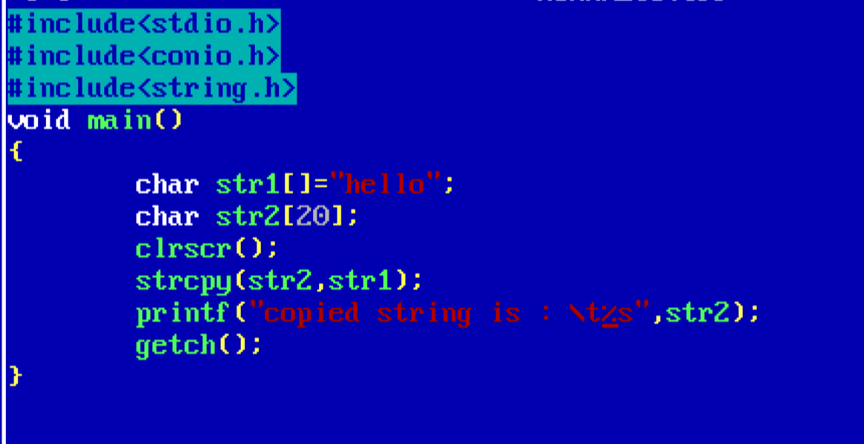*Output:**

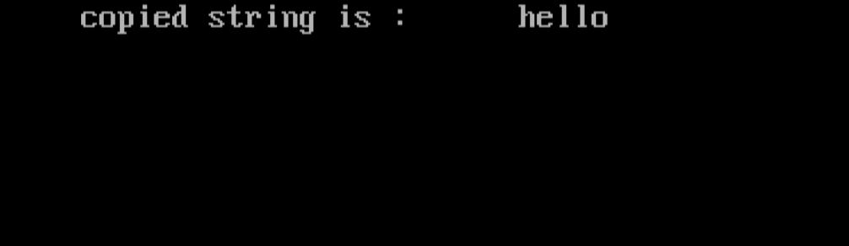

5.strcmp():

Used to compare two strings.

Eg: program to compare two strings.

***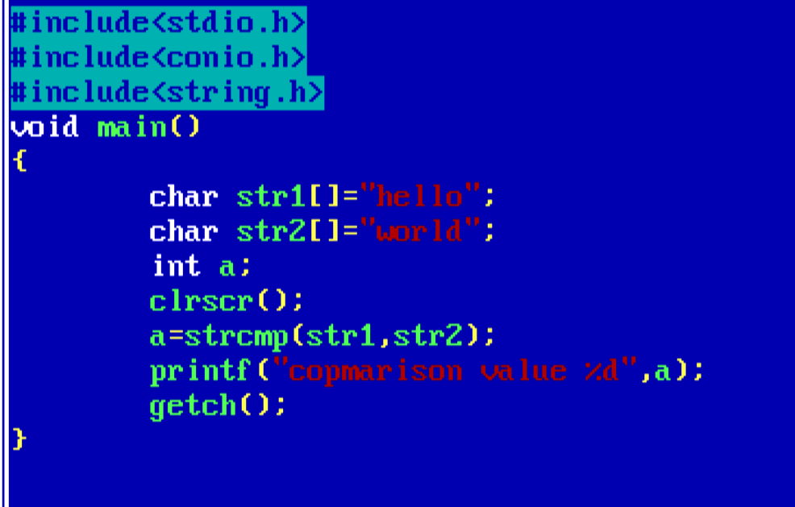*Output:**

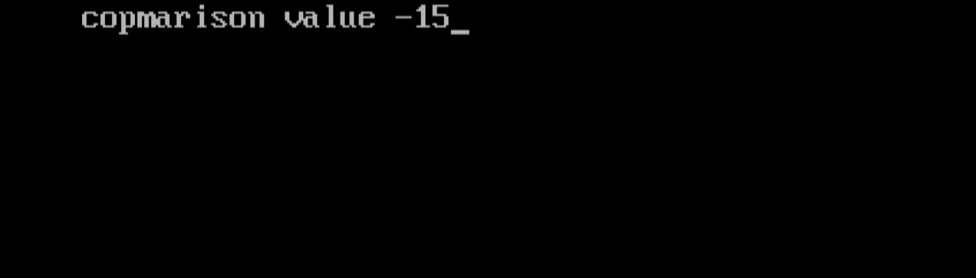

6.strlwr():

Used to convert the string into lower case.

**Eg**: program to convert the string to lower case.

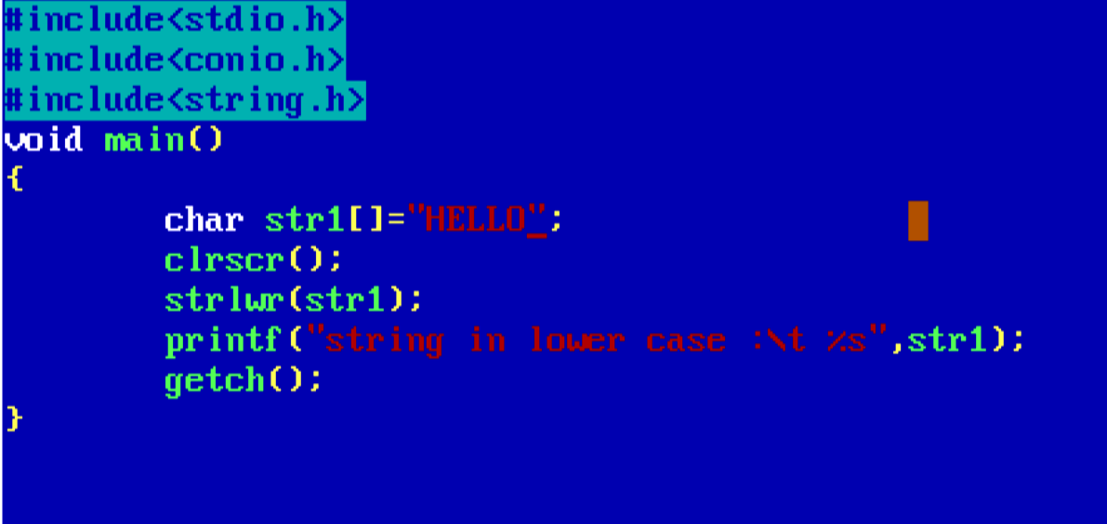

**Output:**

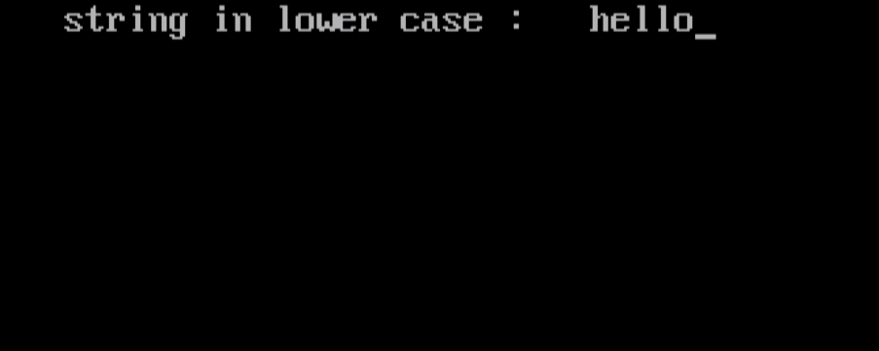

7.strupr():

Used to convert the string into upper case letters

**Eg**: program to convert the string to uppercase

***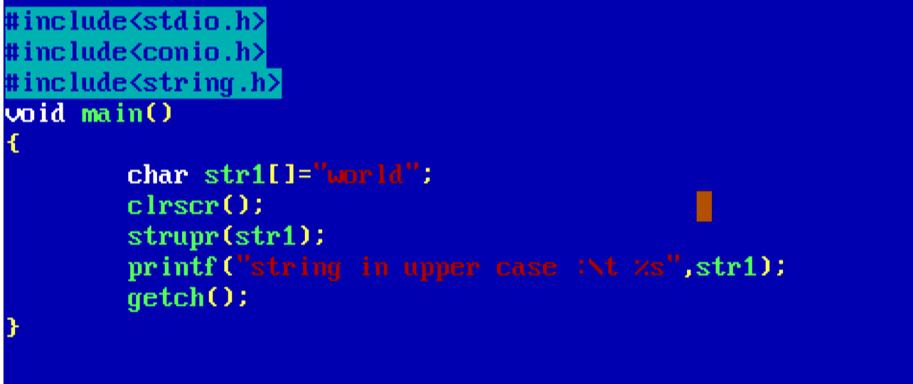* Output:**

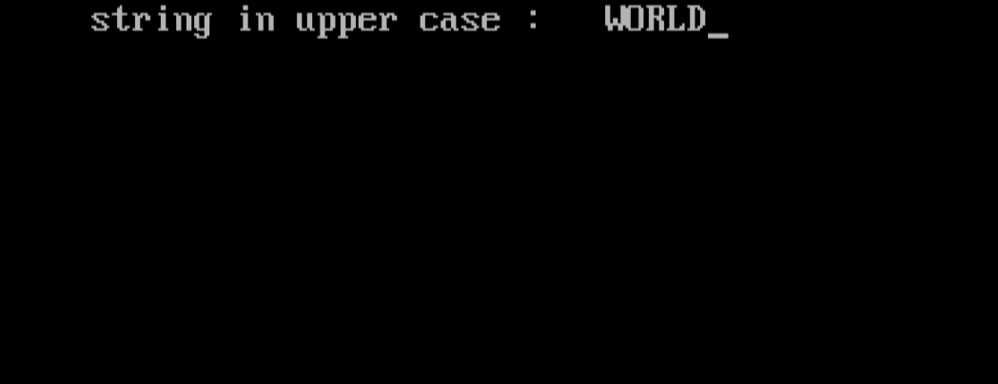

8.strncat():

Used to concatenate n characters of second string to first string

**Eg**: program to concatenate n characters of string to another string

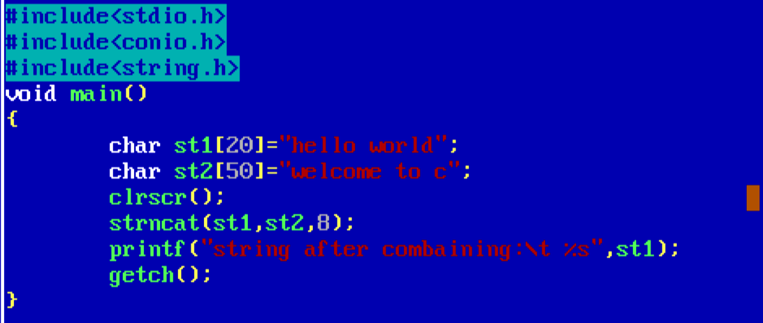

**Output:**

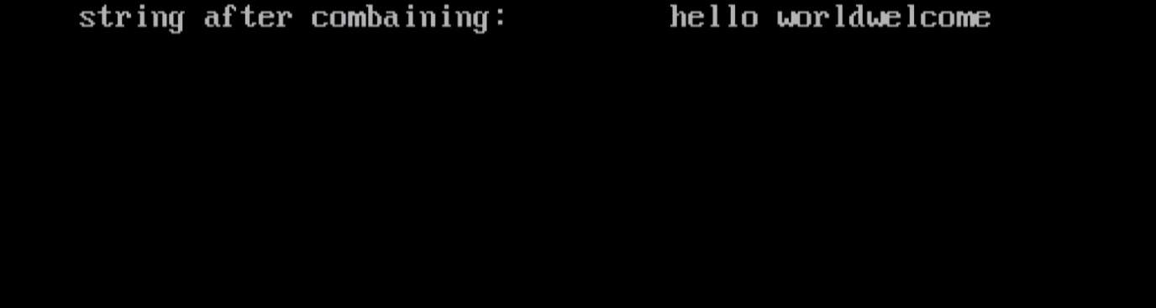

9.strncpy():

Copies up to n characters from a string to another.

**Eg**: program to copy n characters form a string to another.

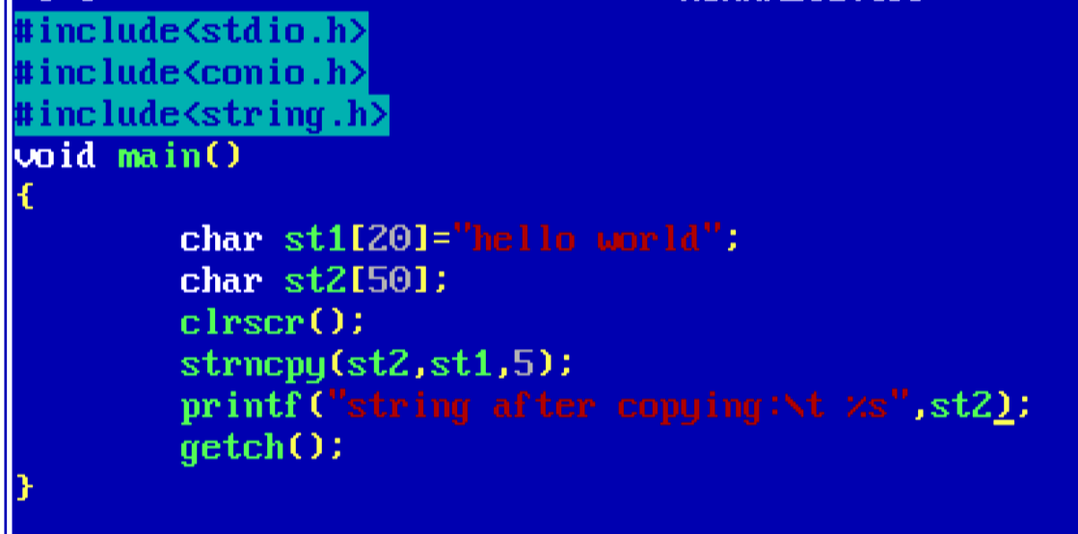

**Output:**

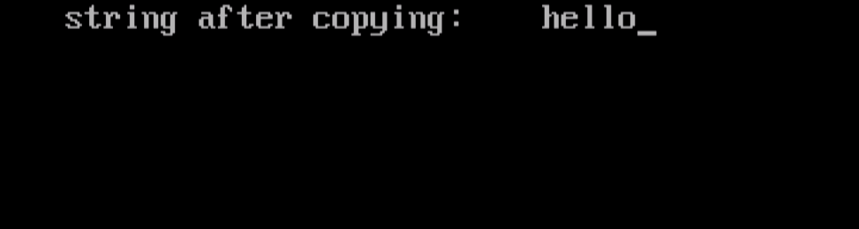

**10.strstr()**:

It returns the first occurance of str2 in str1. The syntax is strstr(str1,str2).

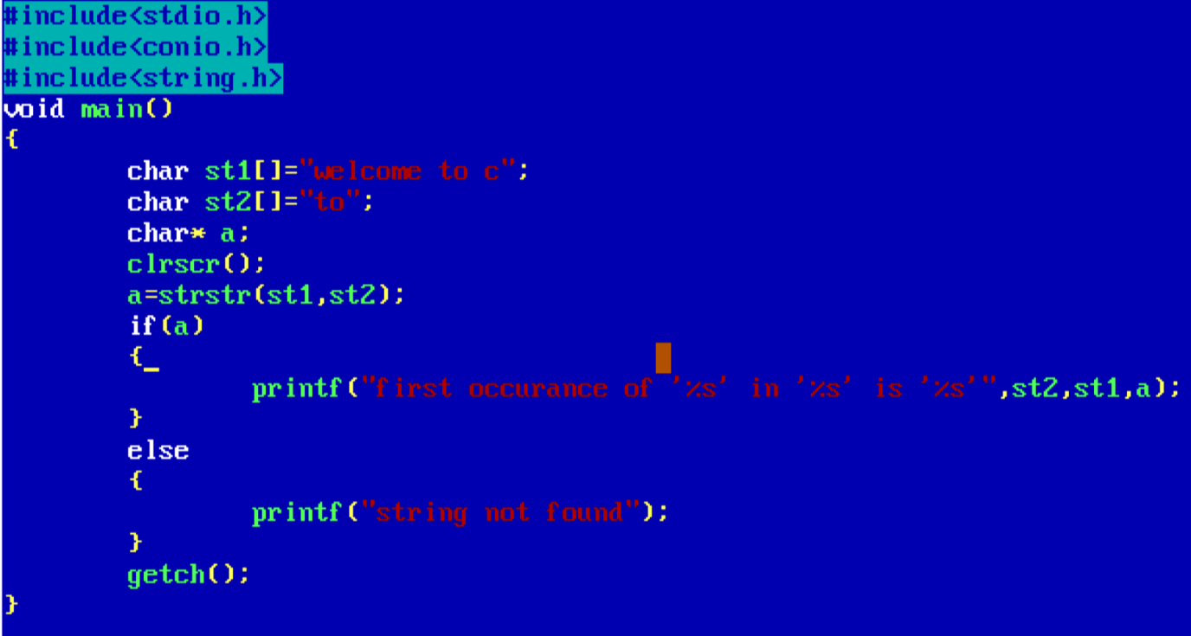

**Output:**

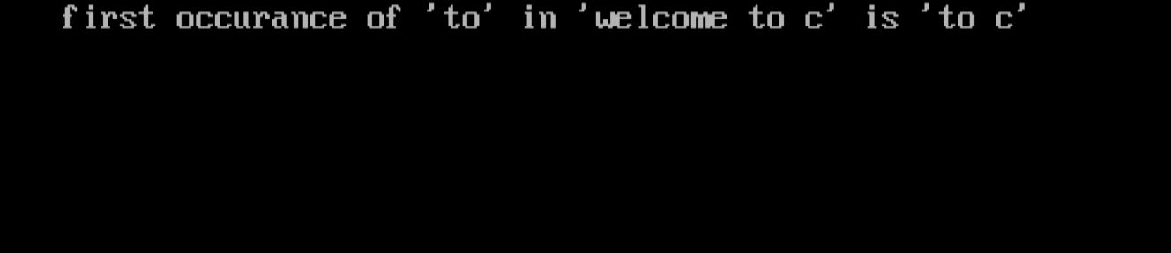

Submitted by Melbin Jojo

Roll no:22

S1 BCA

SB college changanassery